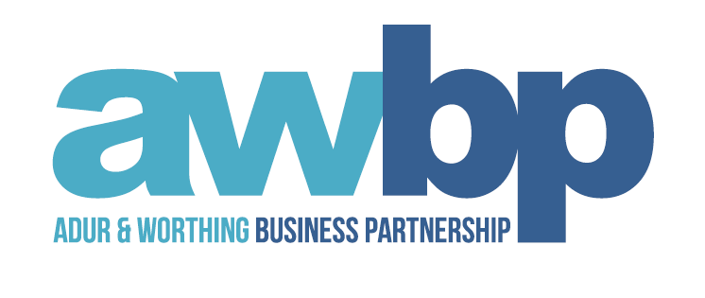

Adur and Worthing Business Partnership
Partnership Meeting

Tuesday 17 JULY 2018
14:30 to 16:45

AGENDA

1. Welcome and Apologies
Present: Andy Willems Andrew Swayne Chris Coopey Martin Randall John Haffenden Brian Boggis Anne Feldberg Peter Webb , Ann Swain Kevin Jenkins Tim Hague Damian Pulford, Beki Tonks, Julie Oakley, Caroline Wood
Guest – Sharon Collett, Grant Baker, Daryl Parsons
Apologies: Martin Sacree, Joel Hufford, Paul Riley, Tina Tilley

2. Minutes & Actions from the meeting held on 17 April 2018
ACTION: Letter to WSCC needs to be drafted by AC, to be agreed by AS

3. AWBP Action Plan: Progress report (Andrew Swayne/Andy Willems)
Action plan has been reviewed by AW and AS. Agreed a further meeting is required to ensure the plan is aligned with developments from the recent Greater Brighton Economic Board and publication of Coast 2 Capitals Strategic Economic Plan.
Item 3 aligns well with today’s presentation by Grant Baker
Items 4 & 6 align well with Gigabit project and Paul Brewer will be asked to attend October meeting to discuss Gigabit. AS brought up the issue of gaps in infrastructure. MR reassured the Partnership that the project will be rolled out as comprehensively as possible. Paul Brewer will explain in more detail how we are approaching the project. AS confirmed we are a test area but are well placed to roll this out.
MR suggested making more use of the ‘Build Adur & Worthing’ magazine. Discussion followed on best way to distribute as email inboxes become too full to accept digital version.
MR highlighted the need for more attention to high value manufacturing as these align with the Economic Strategy. Partnership agreed. Anne Swaine suggested the partnership investigate figures on start up businesses.
ACTION: Updated Action Plan to be circulated by AS/AW
ACTION: Partnership agreed more paper copies to be distributed around the town
ACTION: BT – to investigate getting Building AW into school newsletters

4. Coast 2 Capital Growth Hub update (presentation - Grant Baker)
Grant Baker provided update on the C2C Growth Hub. Confirmed the Hub no longer look to support start up businesses as a priority, but now have small businesses as a priority with £200K+ turn over, limited company status & trading for 12 months. Provide a diagnostic and then refer to quality signposts. Start ups are now referred to other organisations. Aware this is a small remit but request help from the Partnership for referrals.
Grant Baker specialises in growth loans, bank loans, cashflow, business plan and application ready. Works closely with BT and hopefully will have some funding in time to support education/skills initiative. Partnership requested case studies to help them refer appropriate companies.
ACTION: requires success stories from GB

5. How businesses can work with University of Brighton (presentation - Daryl Parsons)
The KEEP project is a collaboration of 6 universities helping businesses to launch new products. A company can claim up to 50% towards research. Offers a menu of support including access to money through to consultancy. Eligible companies can’t have more than £200k turnover.
ACTION: DP to provide further details to send out with the minutes (see below)
I have embedded a link here for you, this will provide you with a flavour of our latest project that we have been engaged with. The following link will provide information on some of the area that I covered in the meeting and may help to direct business contacts too. Regards Daryl Parsons

6. Partner updates

- Greater Brighton Economic Board (Andrew Swayne/Martin Randall)
Still no news on A27. Very frustrating and AS will continue to pursue Highways for an update. More funding likely to be released across the area (through the Coast2Capital Strategic Economic Plan/Local Industrial Strategies). AWBP need to be kept informed of the SEP progress and roll out.

- Small Business Growth Grants (Angela Crane)
Worthing fund is running low. Likely to be fully committed by September. Adur still has funding available and Partnership encouraged to promote.

- Apprenticeship Fair
Great success as a benchmark. Requires more promotion next year. See attached report.

- Careers Fairs (Beki Tonks/Angela Crane) AWBP approved £1500 towards Transport costs.
- ACTION: BT to invoice AWBP

9. AOB
ACTION – check portal partners are up to date
Next Meeting:
16 October 2018
Worthing College
Sanditon Way
Worthing, BN14 9FD

